Project Design Phase-II
Data Flow Diagram & User Stories

Date | 25 June 2026
Team ID
Project Name | A Comprehensive Measure of Well-Being
Maximum Marks | 4 Marks

Data Flow Diagrams:
A Data Flow Diagram (DFD) is a traditional visual representation of the information flows within a system. A neat and clear DFD can depict the right amount of the system requirement graphically. It shows how data enters and leaves the system, what changes the information, and where data is stored.

Example:
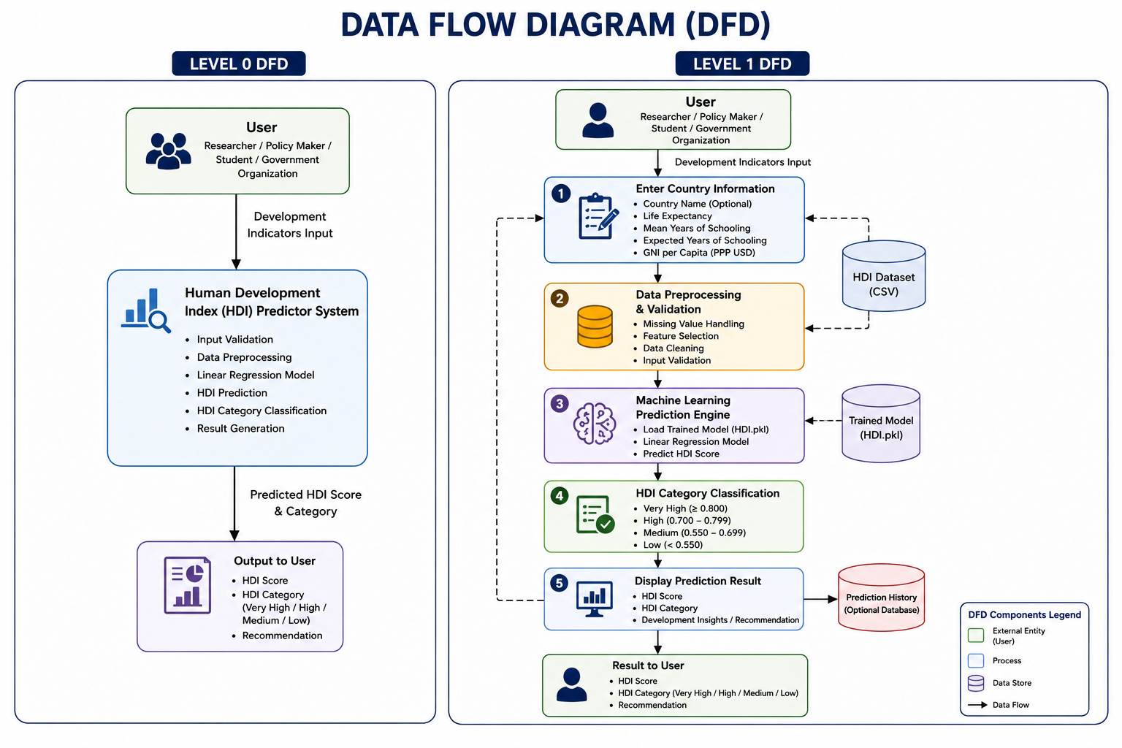

User Stories
Use the below template to list all the user stories for the product.

Researcher

User Type | Functional Requirement (Epic) | User Story Number | User Story / Task | Acceptance Criteria | Priority | Release
Researcher | HDI Prediction | USN-1 | As a researcher, I can enter development indicators to predict the HDI score. | User inputs are accepted successfully and prediction is generated. | High | Sprint-1
Researcher | Result Viewing | USN-2 | As a researcher, I can view the predicted HDI score and category. | HDI score and category are displayed correctly. | High | Sprint-1
Researcher | Country Comparison | USN-3 | As a researcher, I can compare development levels of different countries. | Country comparison is displayed successfully. | Medium | Sprint-2

Policy Maker

User Type | Functional Requirement (Epic) | User Story Number | User Story / Task | Acceptance Criteria | Priority | Release
Policy Maker | Development Analysis | USN-4 | As a policy maker, I can analyze HDI predictions for decision-making. | Accurate prediction results are available. | High | Sprint-1
Policy Maker | Development Planning | USN-5 | As a policy maker, I can identify countries requiring development improvements. | Countries with lower HDI are identified correctly. | High | Sprint-2
Policy Maker | Report Generation | USN-6 | As a policy maker, I can generate reports based on HDI predictions. | Reports are generated successfully. | Medium | Sprint-2

Student / Data Analyst

User Type | Functional Requirement (Epic) | User Story Number | User Story / Task | Acceptance Criteria | Priority | Release
Student / Data Analyst | Data Visualization | USN-7 | As a student, I can view charts and visualizations of HDI data. | Charts are displayed correctly. | Medium | Sprint-2
Student / Data Analyst | Model Evaluation | USN-8 | As a student, I can analyze model performance using evaluation metrics. | R² Score and performance metrics are displayed successfully. | Medium | Sprint-2

